Central York Jr Panther Cheerleading
Rules, Regulations and Guidelines
Est. 7/8/2025

Central York Jr Panthers Cheerleading Program Guidelines
The following rules are adopted by the Central York Jr Panthers Cheerleading program while cheering on the sidelines during youth rec league games. The intent of these rules is to provide an easy-to-understand set of rules for practice and game environments.
Disclaimer: The Cheer Director and CYJP Board of Directors, together, will have the authority to amend/update or temporarily approve changes based on their discretion or as needed throughout the season.

Season Meetings:
- Mandatory Uniform Try-On Dates (dates TBD; Fall Season Only)
- Mandatory Coaches Meeting
- Mandatory Parents Meeting
- Mandatory Pre-Season Camp (two weeks; Fall Season Only)
- Mandatory Uniform Turn in Dates (dates TBD)

General Rules for ALL Levels:
- Practice and games are considered mandatory. If you will not be in attendance, you must reach out to the appropriate coach and notify them as soon as feasible. To be included in stunts during games, the athlete must have participated in practice and prior to the game warmups. If the athlete is not present, a substitute may be utilized.
- All cheer coaches must have current background screenings and have provided copies to the Cheer Director prior to first practice. If required by the league, all cheer staff must wear their badges visibly at all activities, events, practices and games.
- All legal skills for sideline cheering can be performed on artificial/live grass, rubberized track, indoor basketball court or a mated surface. No skills are allowed on asphalt, concrete or any other similar surface.
- Fingernails, including artificial nails, must be kept short, near the end of the fingers.
- Hair must be worn in a manner that is appropriate for the activity involved. Hair devices and accessories must be secure. In general, hair should be pulled back away from the face and secured.
- Necklaces, bracelets and hoop earrings are not permitted. Only plain basic stud earrings are allowed. A religious medal without a chain is allowed but must be taped and worn under the uniform. A medical‐alert medal must be taped and may be visible.
- Participants must not chew gum or have candy in their mouths during practices or games.
- The only props allowed to be used are megaphones, poms, signs and flags. The only props allowed to be used while in stunts or pyramids are poms or signs in use by the top person only. A top can hand a sign to a base or spotter with the intent of immediately releasing it to the ground if the top is not extended. Props must be approved and/or provided by Cheer Director or CYJP directly.
- Sponsors/coaches must recognize their squad's specific ability level and must limit the squad's activities accordingly. "Ability level" refers to the squad's talents, and individuals should not be pressed to perform activities until safely perfected. Coaches are to consult with the Cheer Director and even possibly the CYJP Board when appropriate for levels of stunts and squad’s capabilities.
- Any participant who exhibits signs, symptoms, or behavior consistent with a concussion (such as loss of consciousness, headache, dizziness, confusion, or balance problems) shall be immediately removed from the activity/practice/event/game and shall not return to play until cleared by an appropriate health-care professional.
- When the area where the cheer squad is participating whether it is an activity/event/game/practice is considered damp and/or wet, either from rain or other unknown influence(s), then stunting will be prohibited until the area is deemed dry and safe for stunting. All cheer coaches should take caution in deciding if the wet area is safe for jumping.
- Tumbling and stunt mats should be always used during practices when actively working on either of those activities.
- Incidents other than minor first aid will be reported to the Cheer Director using an incident report form. Depending on the severity of the incident, the CYJP Board will be involved. Any incidents will prompt notice to parents at pick up from event, or if needed, require parent intervention immediately following incident.
- We expect cheerleaders and parents to be respectful during practices, games and towards opposing teams. Cheerleaders should always have their listening ears on for coaches and parent volunteers. It is imperative that we maintain a safe and inclusive environment for all our members. If behavior becomes an issue, the Cheer Director, with possible involvement from the CYJP Board will intervene and provide warnings, and eventually dismissal from the program.

Definitions (Photos Available):
Base: A person in direct weight‐bearing contact with the performing surface who provides primary support for another person.
Cradle: A dismount from a partner stunt, pyramid or toss in which the catch is completed below shoulder level height by a base or bases with the top person in a face‐up open‐pike position.
Dismount: Ending a stunt by releasing a top person to the performing surface or a cradle position.
Extension: An extended stunt in which the top has both feet in the hands of a base(s).
Hitch Body Position: A single‐leg stunt where the leg is not providing support is in a liberty type position and the hip is open.
Inverted Position: Shoulders are below the waist.
Liberty: A multi‐based, single‐leg stunt where the leg not providing support is pulled to approximately a 90‐degree angle with the hips of the athlete performing the skill, including the hitch variation.
Toss: A release stunt in which the base(s) begin underneath the top person’s foot/feet and execute a throwing motion from below shoulder level to increase the height of the top person. The top person becomes free from all bases, spotters, posts or bracers.

Category | Rink  (Grades K-2) | Pony  (Grades 3-4) | Midget  (Grades 5-7)
Jumps | All jumps and jump combinations allowed. | All jumps and connections to  tumbling allowed. | All jumps and connections to  tumbling allowed.
Tumbling | Forward and backward rolls. Forward and backward walkovers.  Roundoffs, Cartwheels (series cartwheels allowed). | Non‐twisting standing  handsprings and standing back tucks allowed.  Series tumbling allowed.  No twisting airborne skills. | Series tumbling allowed.  No twisting airborne skills.
Stunts | No inversions (the head can never be below the hips). | No inversions (the head can never be below the hips). | No inversions (the head can never be below the hips).
 | No release stunt transitions other than a  reload from a cradle position. | No release stunt transitions other than a  reload from a cradle position. | No release stunt transitions other than a  reload from a cradle position.
 | A spotter is required for all stunts. | A spotter is required for all prep-level stunts and above. | A spotter is required for all extension-level stunts and above.
 | No spinning/twisting. | Half twist loading is allowed.  Full twist to a loading position allowed. | Full twist from a loading position to double base prep and double base  extension allowed.
 | Allow all skills prep level and below.  A standing stunt at prep level must be  double based and standing on both feet.  Transitional stunts may not involve changing bases. All bases need to remain in contact with the stunt. | Double base extensions allowed (coach shall be a part of the stunt for all extensions)  Liberties and liberty hitches at prep level allowed.  Transitional stunts may not involve changing bases. All bases need to remain in contact with the stunt. | Double base extensions are allowed. Extended Liberty/Hitch allowed.  Single base extensions are allowed.  Transitional stunts may not involve changing bases. All bases need to remain in contact with the stunt.
Dismounts | No spinning/twisting. No released dismounts (re-grab hands, use a post and pop down, etc.)  Bump downs only. | Full‐twisting cradles and non‐twisting pop downs allowed. | Full‐twisting cradles and non‐twisting pop downs allowed.
Pyramids | Follow stunt rules. | Follow stunt rules. | Follow stunt rules.  If two connected stunts are extended, the connection must be hand to hand/arm.  Twisting while connected is not allowed.
Baskets | Not Allowed | Pencil/Timer and Toe Touch only. No Twists. | Pencil/Timer and Toe Touch only. No Twists.

Thigh High Level  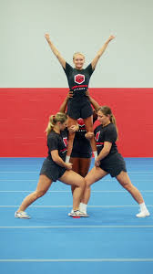 | Teddy Bear  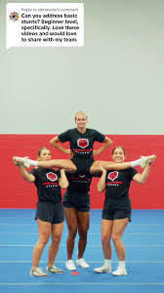  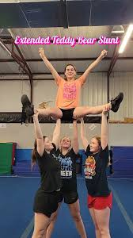 | Prep Level  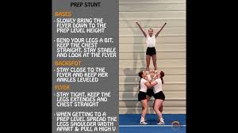 | Extension Level  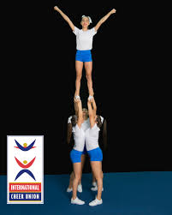 | Single Leg Examples
 |  |  |  | 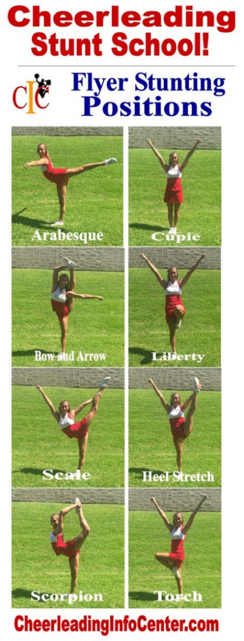
Prep Level Hitch
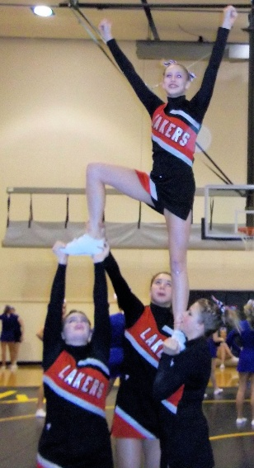
Inversion Position
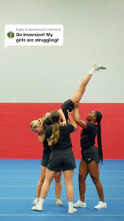

Incident Report Form

Date of Incident: _______________________
Time of Incident: _______________________
Location of Incident: _______________________
Name of Injured Person: _______________________
Contact Information: _______________________
Description of the Incident:

Type of Injury:

Immediate Actions Taken:

Medical Treatment Provided:

Witnesses (if any):
- Name: _______________________ Contact Information: _______________________
- Name: _______________________ Contact Information: _______________________
Reported By:
- Name: _______________________ Contact Information: _______________________
Signature of Reporter: _______________________
----------------------------------------------------------------------------------------------------------------------------

Date: _______________________
Follow-Up Actions Required:

Reviewed By:
- Name: _______________________ Contact Information: _______________________
Signature of Reviewer: _______________________

